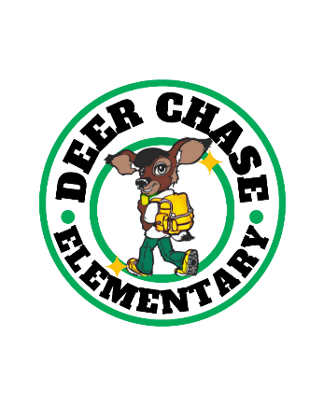 | DEER CHASE ELEMENTARY  2025 – 2026

School Improvement Plan/Strategy Map

STUDENT ACHIEVMENT 1: READING
Objectives
- By May 2026, we will increase the percent of student scoring proficient or above on the EOG ELA GMAS from 19% to 29%.

- By May 2026, we will increase the number of students on grade level from 48% to 73% (236 students to 366) as measured by the EOY i-Ready Reading Diagnostic.

Critical Initiatives
- Integrate ArtsNow strategies & lessons.
- Prescribe explicit reading intervention lessons.
- Facilitate teacher-led school-based professional learning communities focused on literacy.

STUDENT ACHIEVEMENT 2: MATH
Objectives
- By May 2026, we will increase the percent of students scoring proficient or above on the EOG Math GMAS from 16% to 26%.

- By May 2026, we will increase the number of students on grade level from 30% to 60% (174 students to 300) as measured by the EOY i-Ready Math Diagnostic.

Critical Initiatives
- Integrate ArtsNow STEAM project-based learning.
- Prescribe explicit math intervention lessons.
- Facilitate teacher-led school-based professional learning communities focused on numeracy.

POSITIVE LEARNING ENVIRONMENT
Objective
By May 2026, we will increase from 62% to 72% in Perseverance as measured by the EOY Panorama Student Survey.

Critical Initiatives
- Facilitate schoolwide community building segments focused on SEL and leadership skills.
- Continue to implement schoolwide PBIS practices.
- Celebrate students’ persevering through academic and social challenges.

